**Installing Linux on Your Computer using virtualbox**

**Materials Needed:**

* A computer with VirtualBox installed
* A Linux distribution ISO file (e.g., Ubuntu, Fedora)

**Step 1: Download and Install VirtualBox**

Download Virtual box from: **https://www.virtualbox.org/wiki/Downloads**

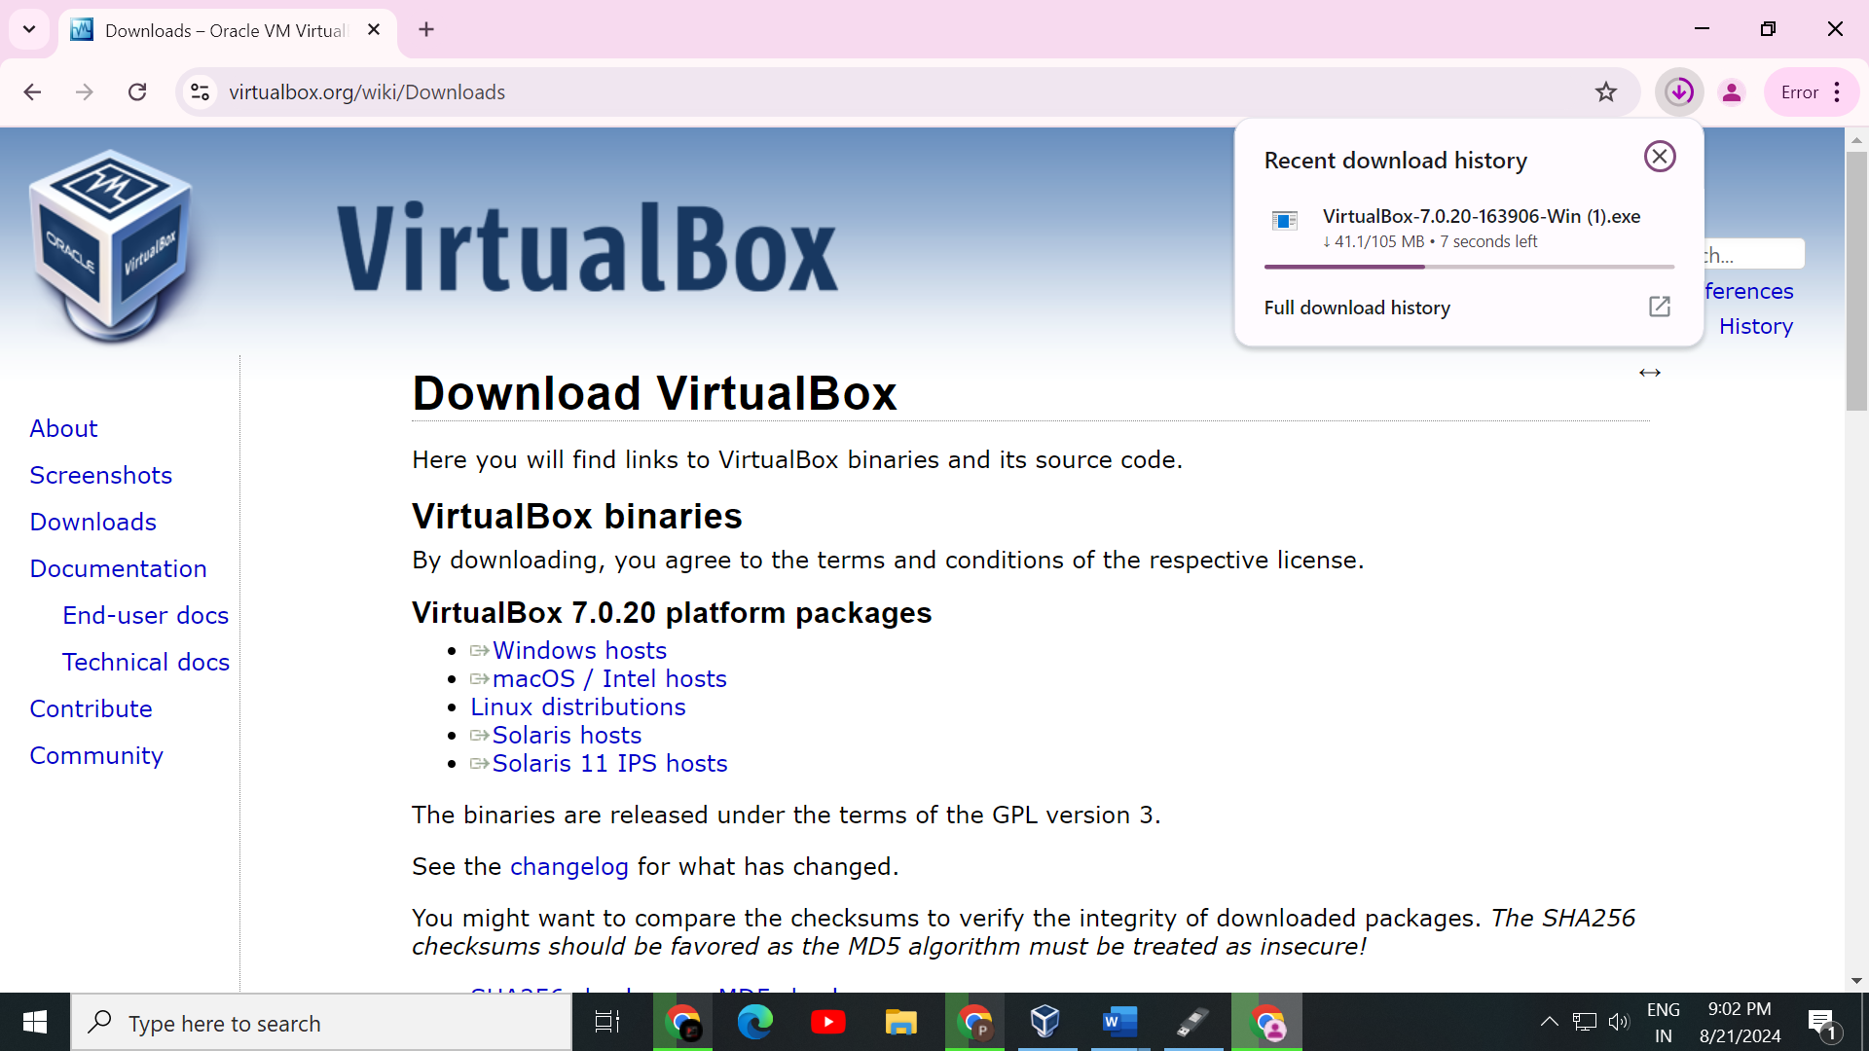

**Step 2: Download the Linux ISO File**

Download Ububtu from**:** [**https://ubuntu.com/download/desktop**](https://ubuntu.com/download/desktop)

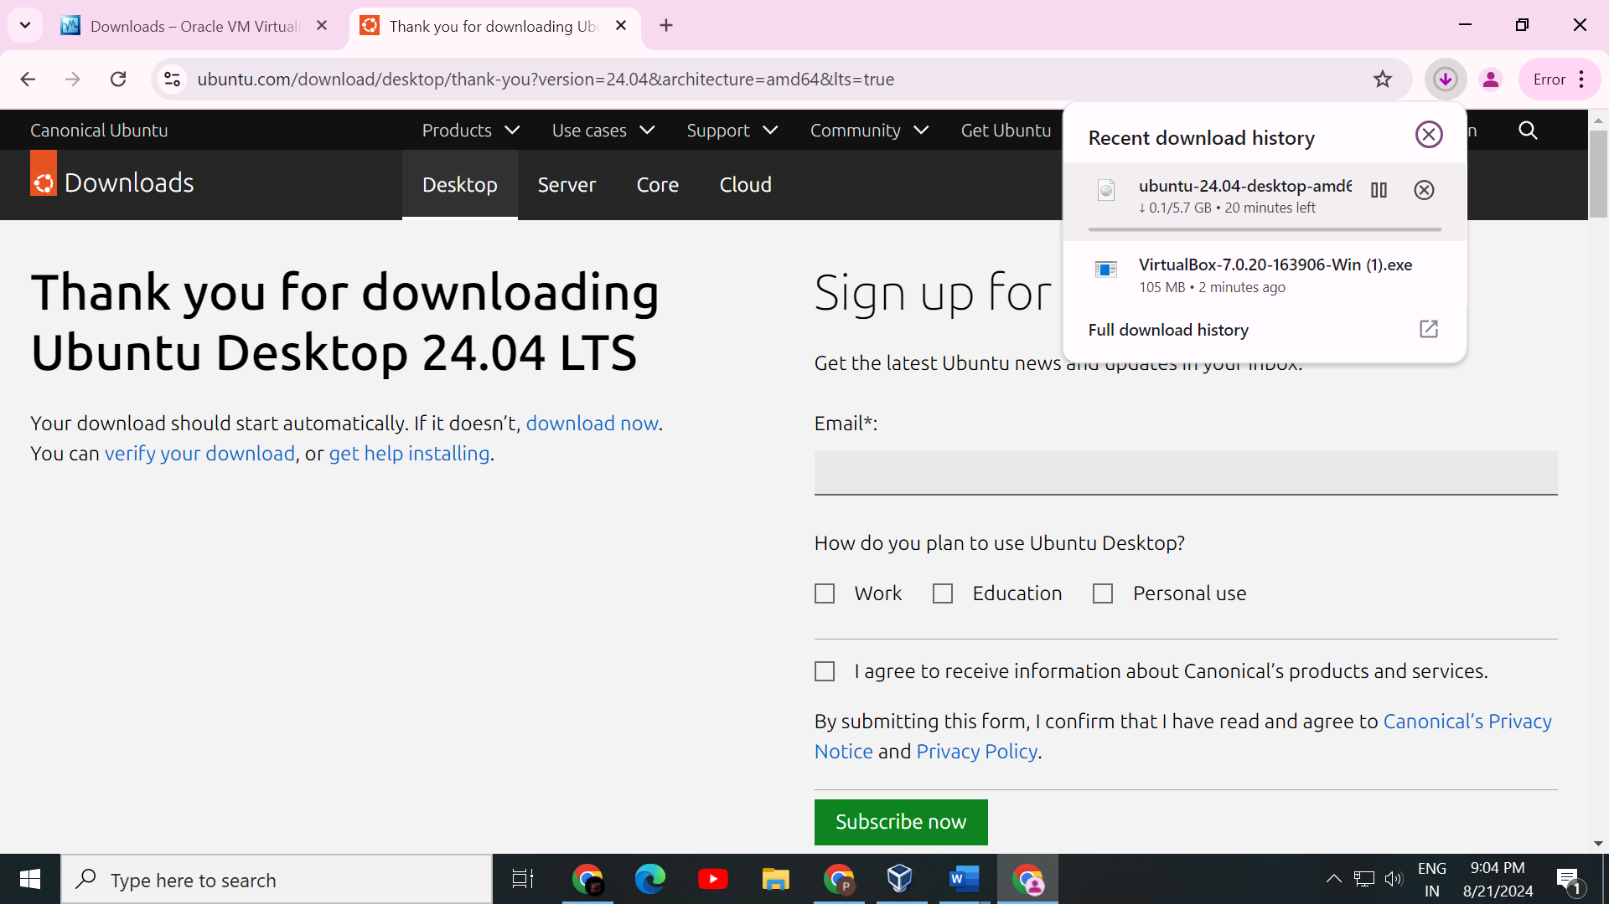

**Step** **3: If your motherboard virtualization is disable then enable virtualization by go to bios advance tab.**

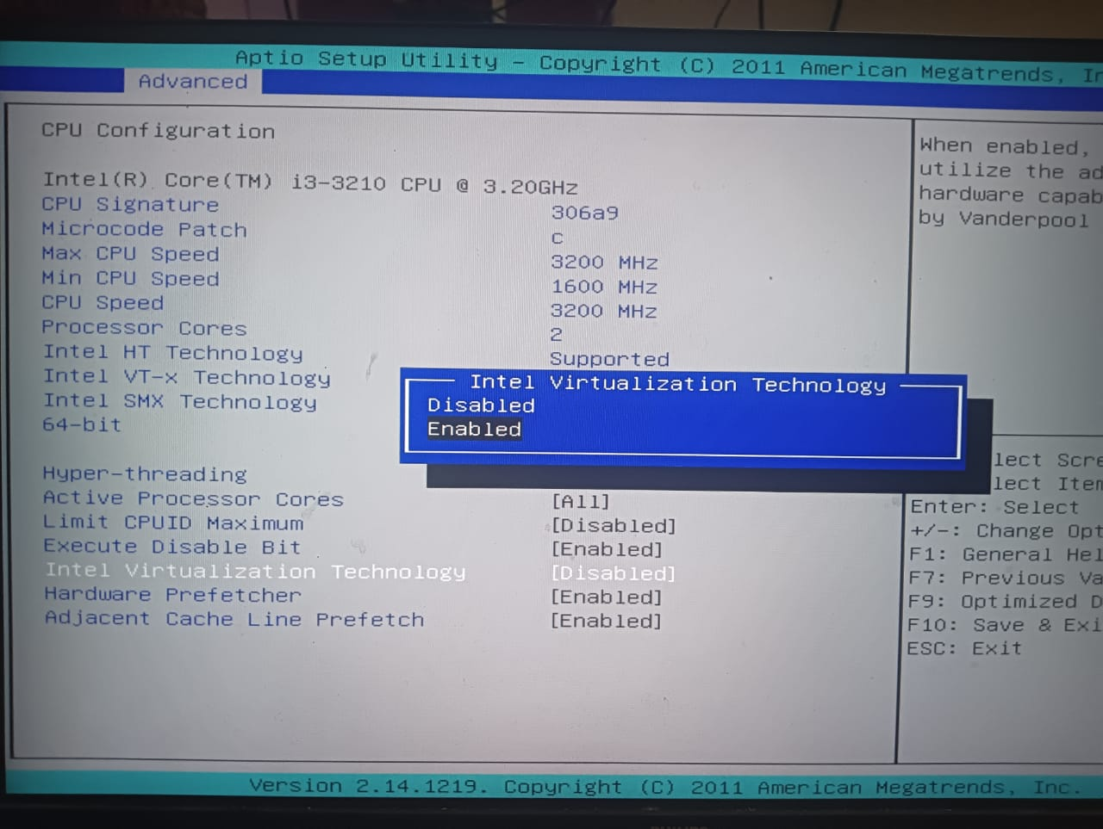

**Step 4: Create a New Virtual Machine**

Open VirtualBox and click "New" to create a new virtual machine.

**Steps:**

1. **Name and Operating System:** Enter a name for virtual machine, choose "Linux" as the type, and select the appropriate version.

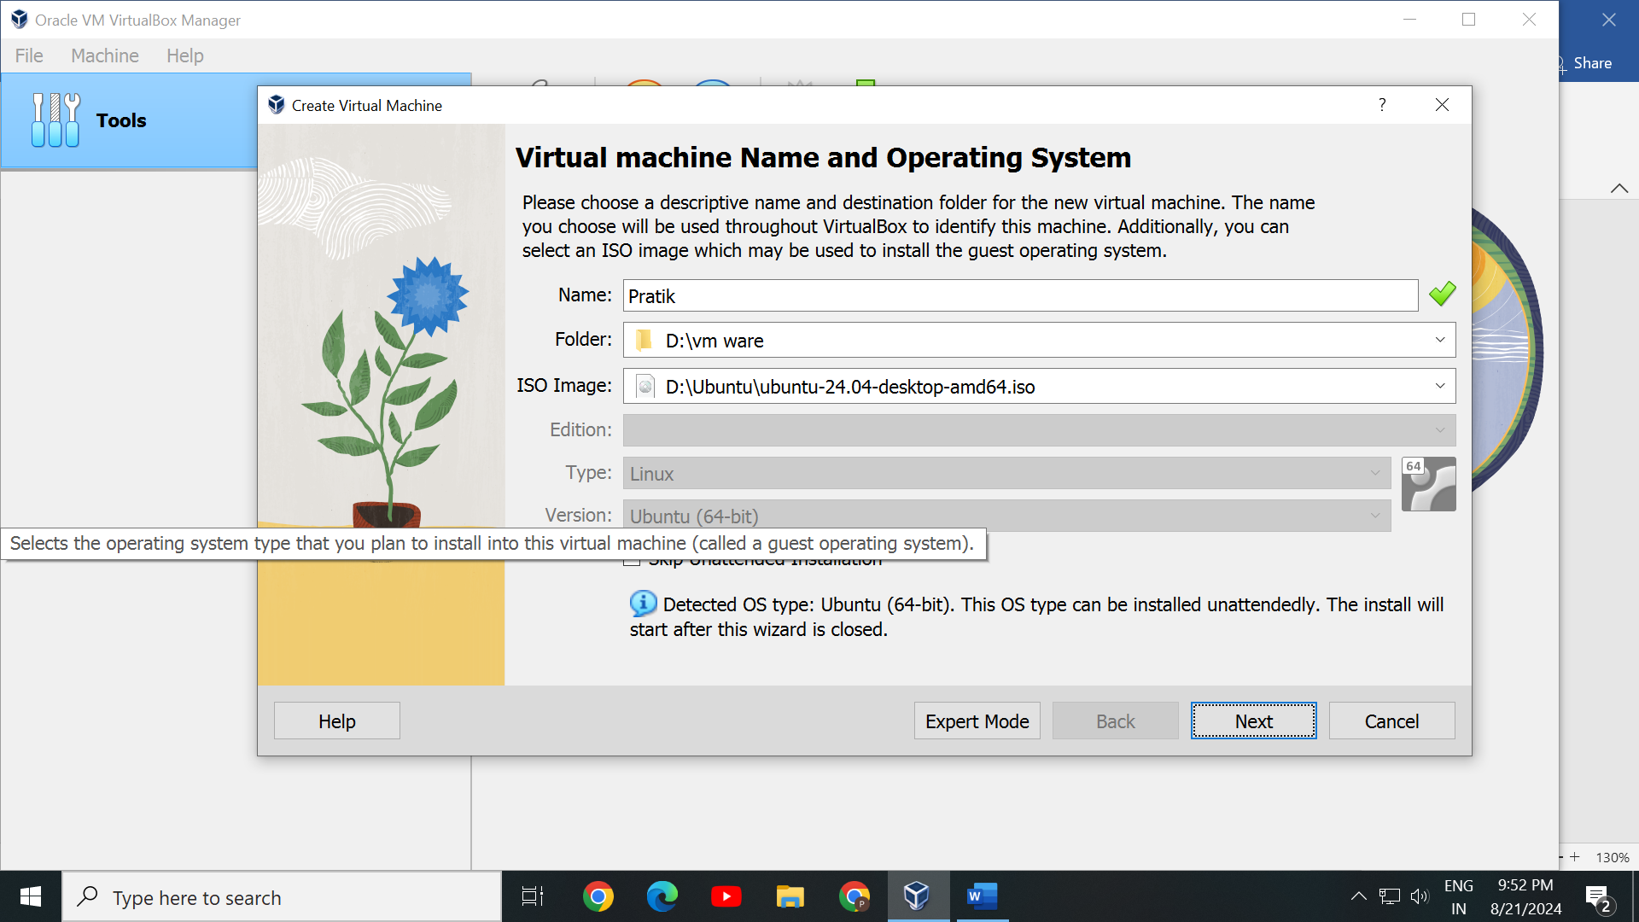

1. **Memory Size and cpu core:** Allocate memory (RAM) to the virtual machine. 2GB (2048MB) is recommended for most distributions.

For cpu you would probably want 2 cores per vm.

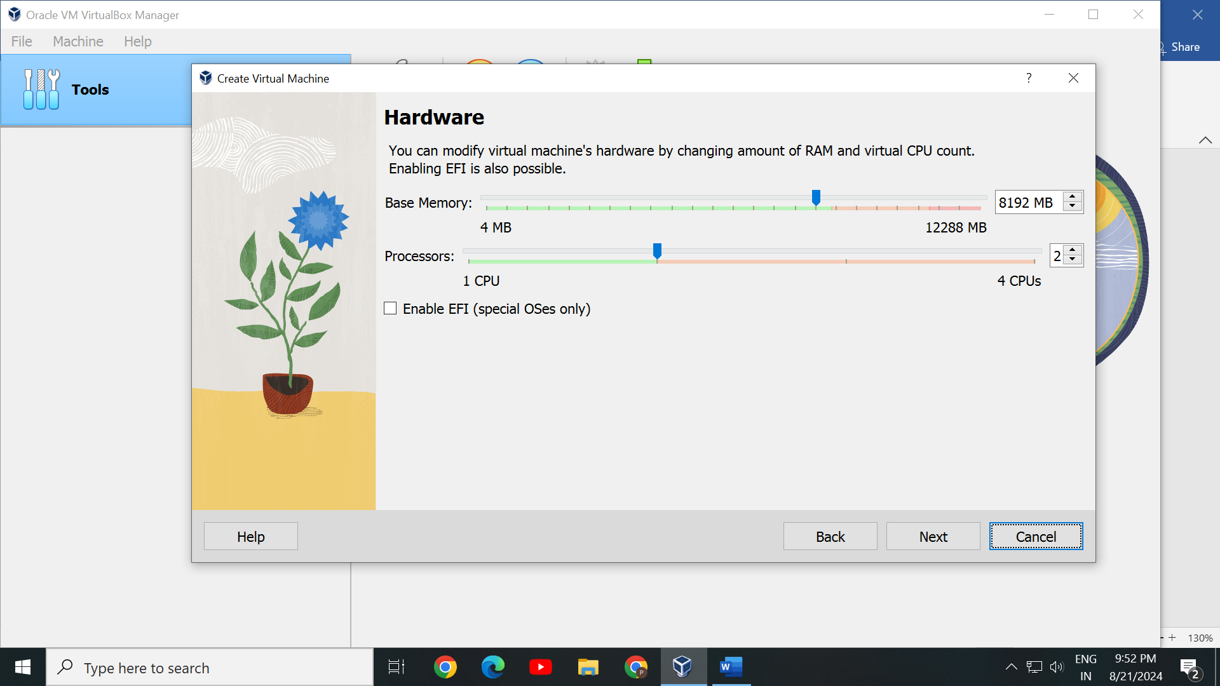

1. **Hard Disk:** Choose "Create a virtual hard disk now" and click "Create."Select "VDI (VirtualBox Disk Image)" and click "Next."**Storage on Physical Hard Disk:** Choose "Dynamically allocated" and click "Next."**File Location and Size:** Select the size of your virtual hard disk (at least 20GB is recommended) and click "Create."

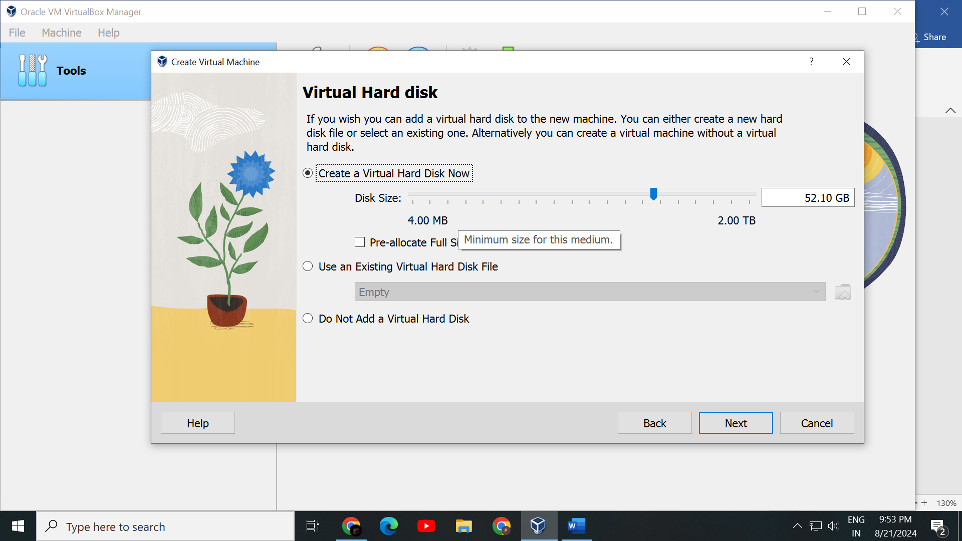

**Step 5: Configure the Virtual Machine**

Before starting the virtual machine, configure some settings.

**Steps:**

1. **Select the Virtual Machine:** Click on your newly created virtual machine and then click "Settings."

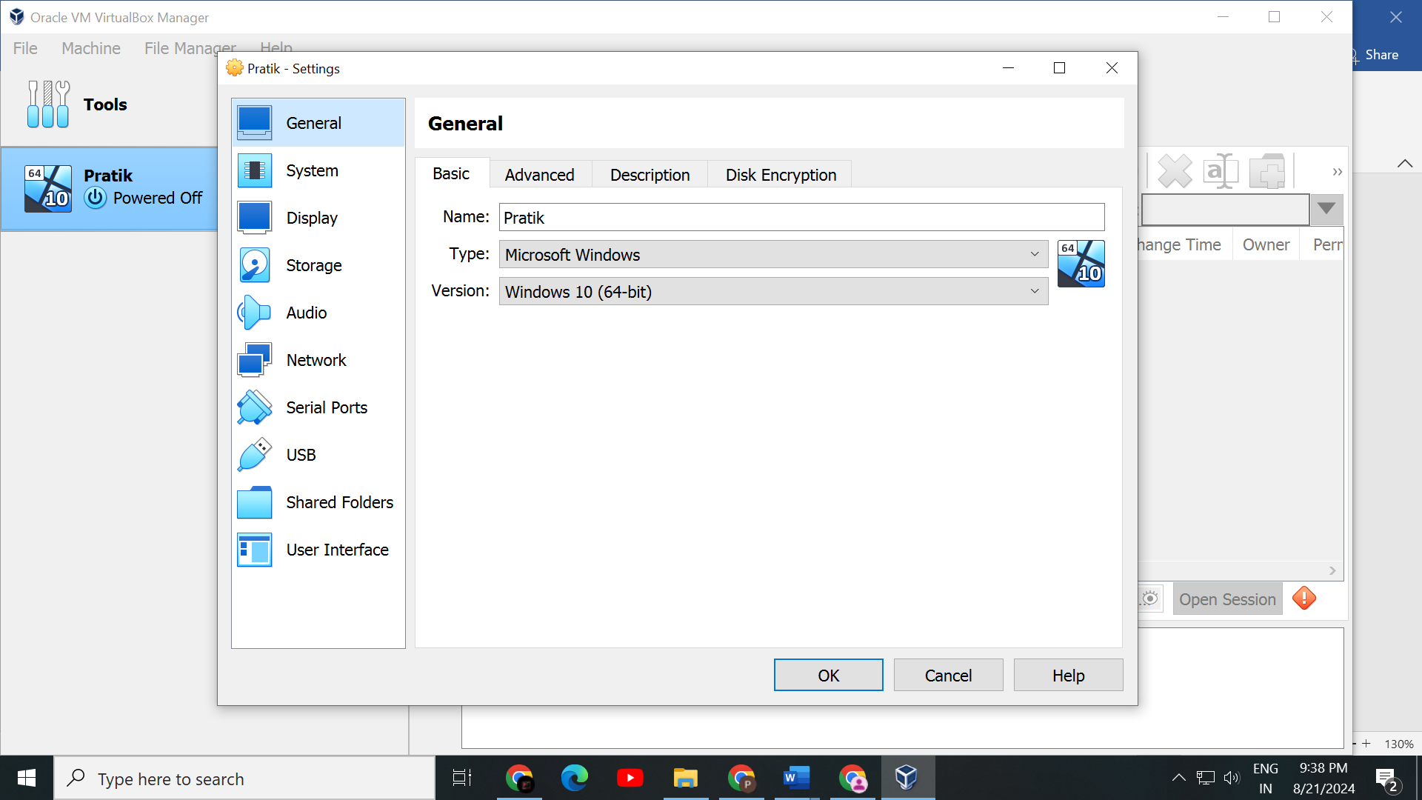

1. **Storage:** In the settings menu, go to "Storage." Under "Controller: IDE," click on the empty disk icon, then click on the disk icon next to "Optical Drive" and select "Choose a disk file." Browse to and select your Linux ISO file.

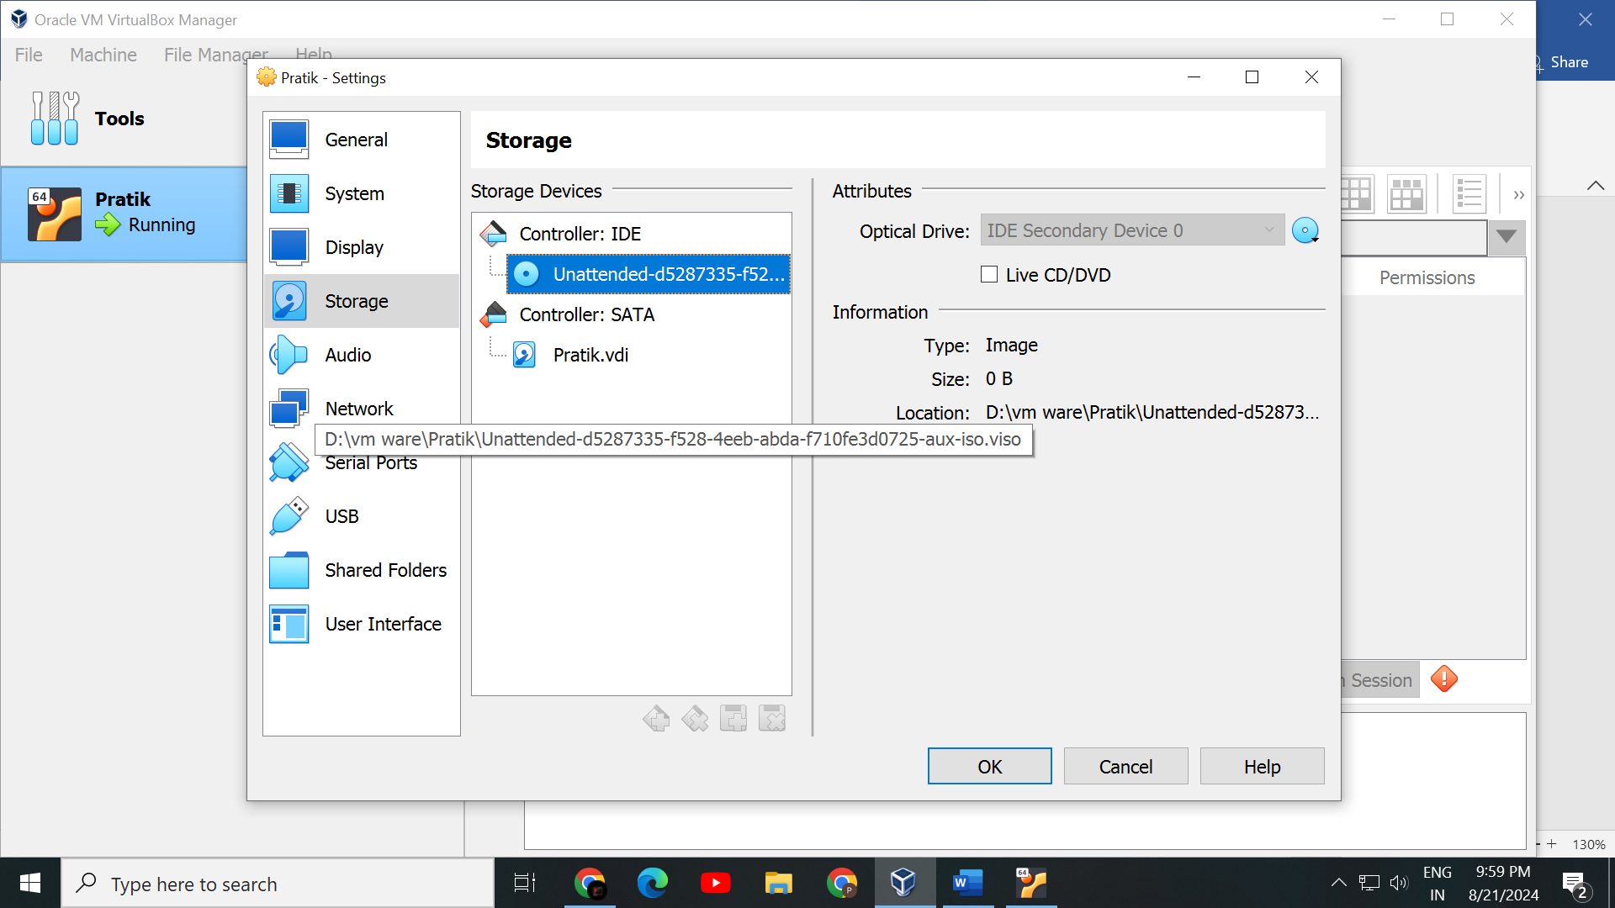

1. **Network:** Go to the "Network" tab and ensure that the adapter is attached to "NAT" to provide internet access to your virtual machine.

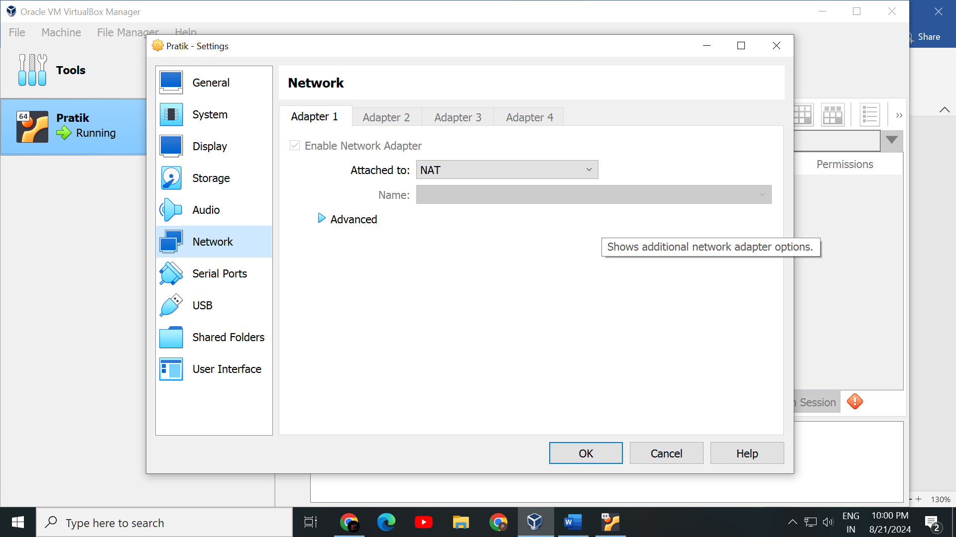

**Step 6: Start the Virtual Machine**

With the ISO file selected, click "Start" to boot the virtual machine. The Linux installer will start automatically.

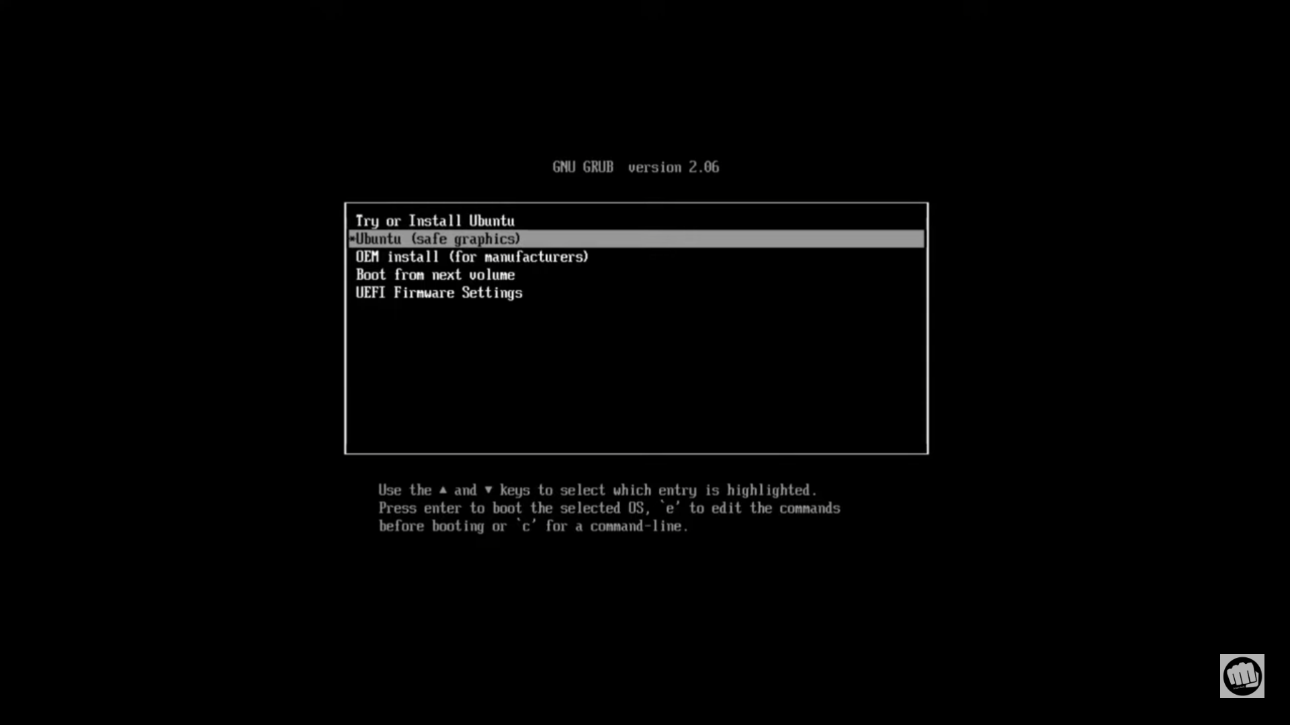

**Step 7:**

**Install Linux**

Follow the on-screen instructions in the Linux installer to complete the installation process.

**Steps:**

1. **Language Selection:** Choose your language and click "Continue."

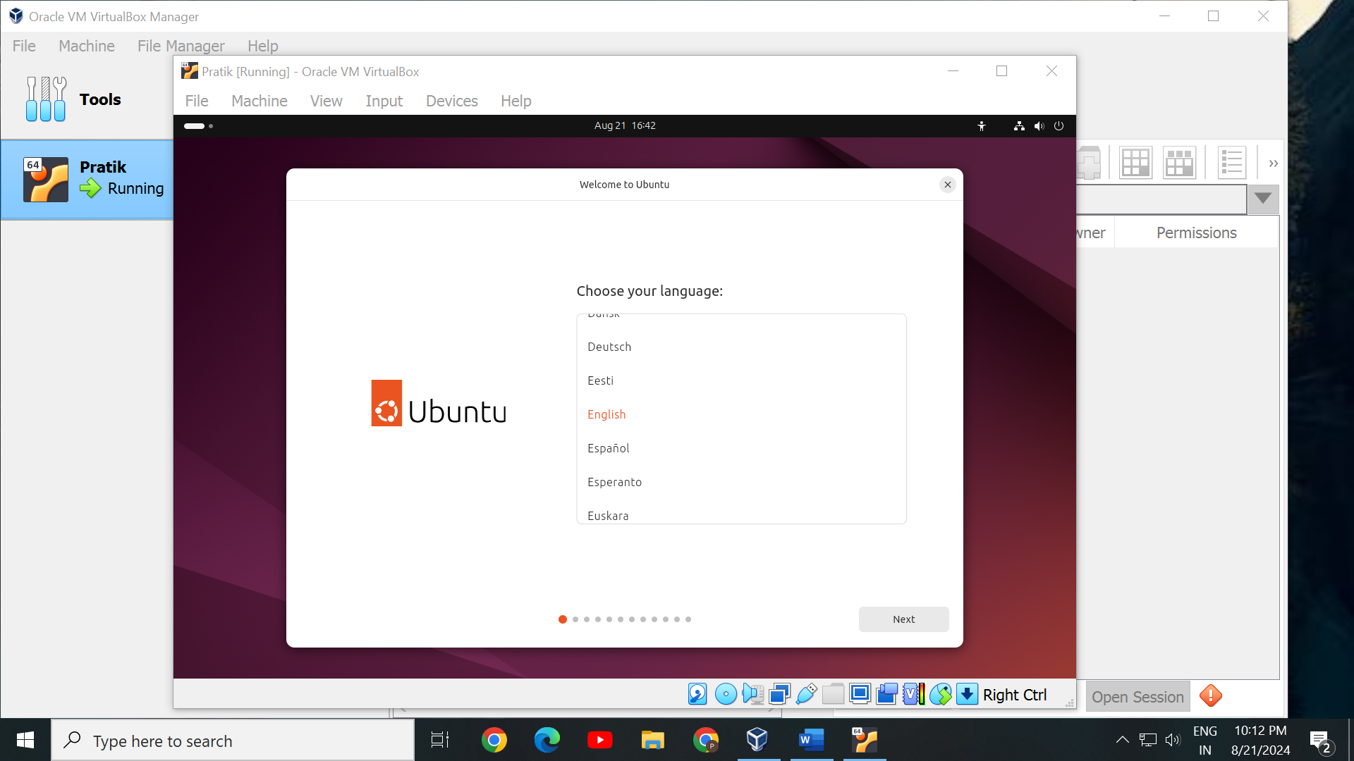

1. **Installation Type:** Choose whether to erase the disk (this only affects the virtual disk) or install Linux alongside other operating systems.

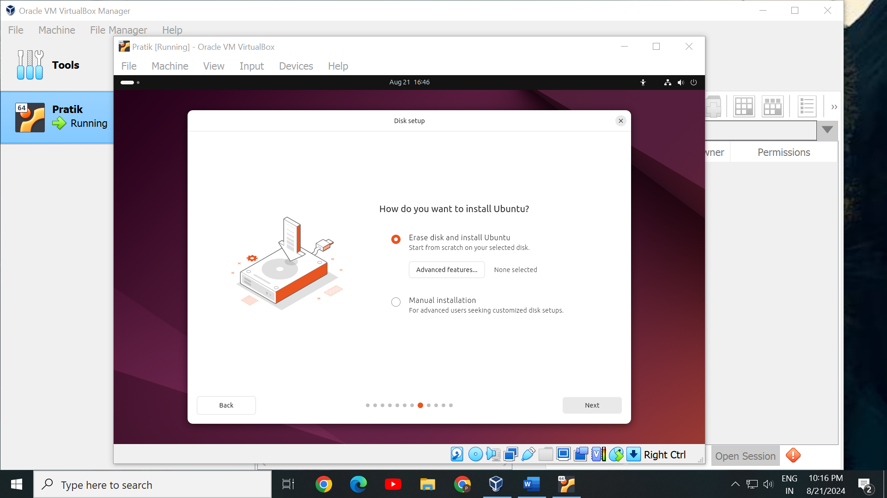

1. **User Information:** Create your user account by entering your name, computer name, username, and password.

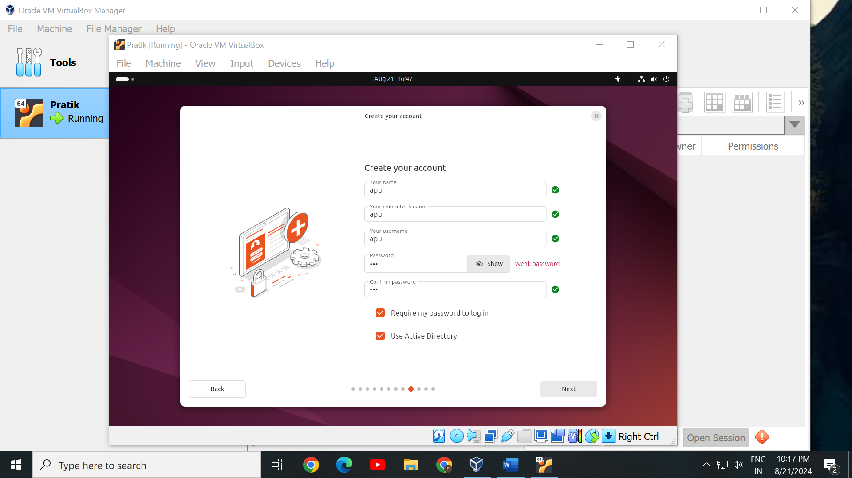

1. **Install:** Click "Install Now" and follow the prompts to complete the installation.

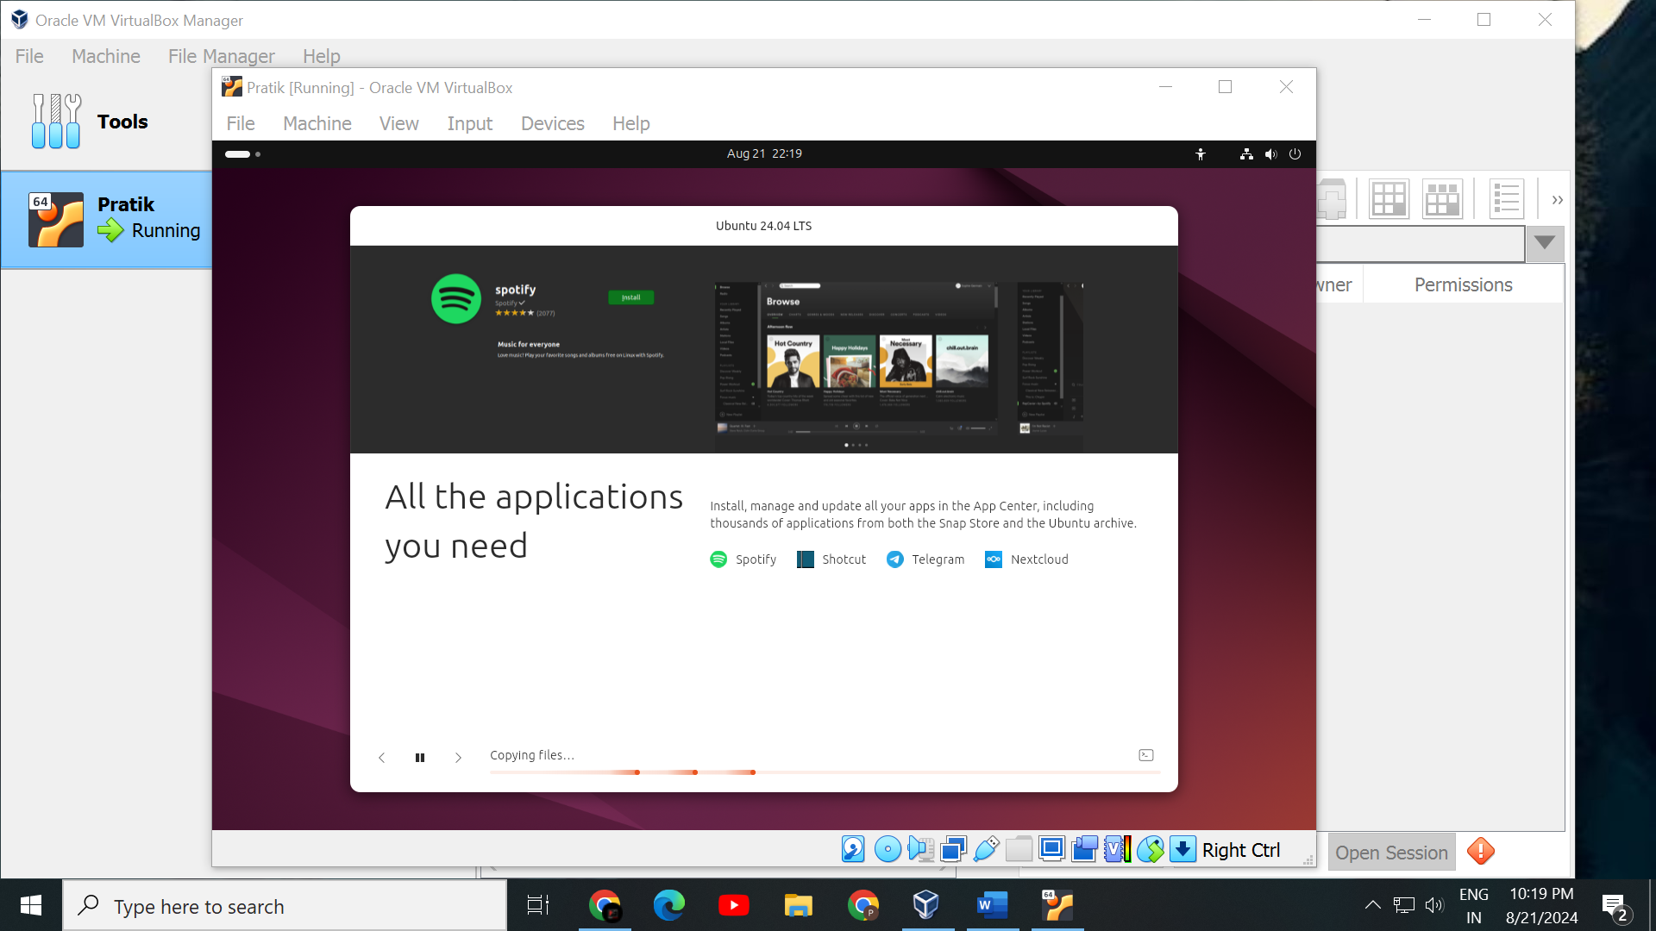

**Step 8: Explore Your New Linux Virtual Machine**

Once your virtual machine restarts, you'll be greeted with the Linux login screen. Log in with the credentials you set during installation.

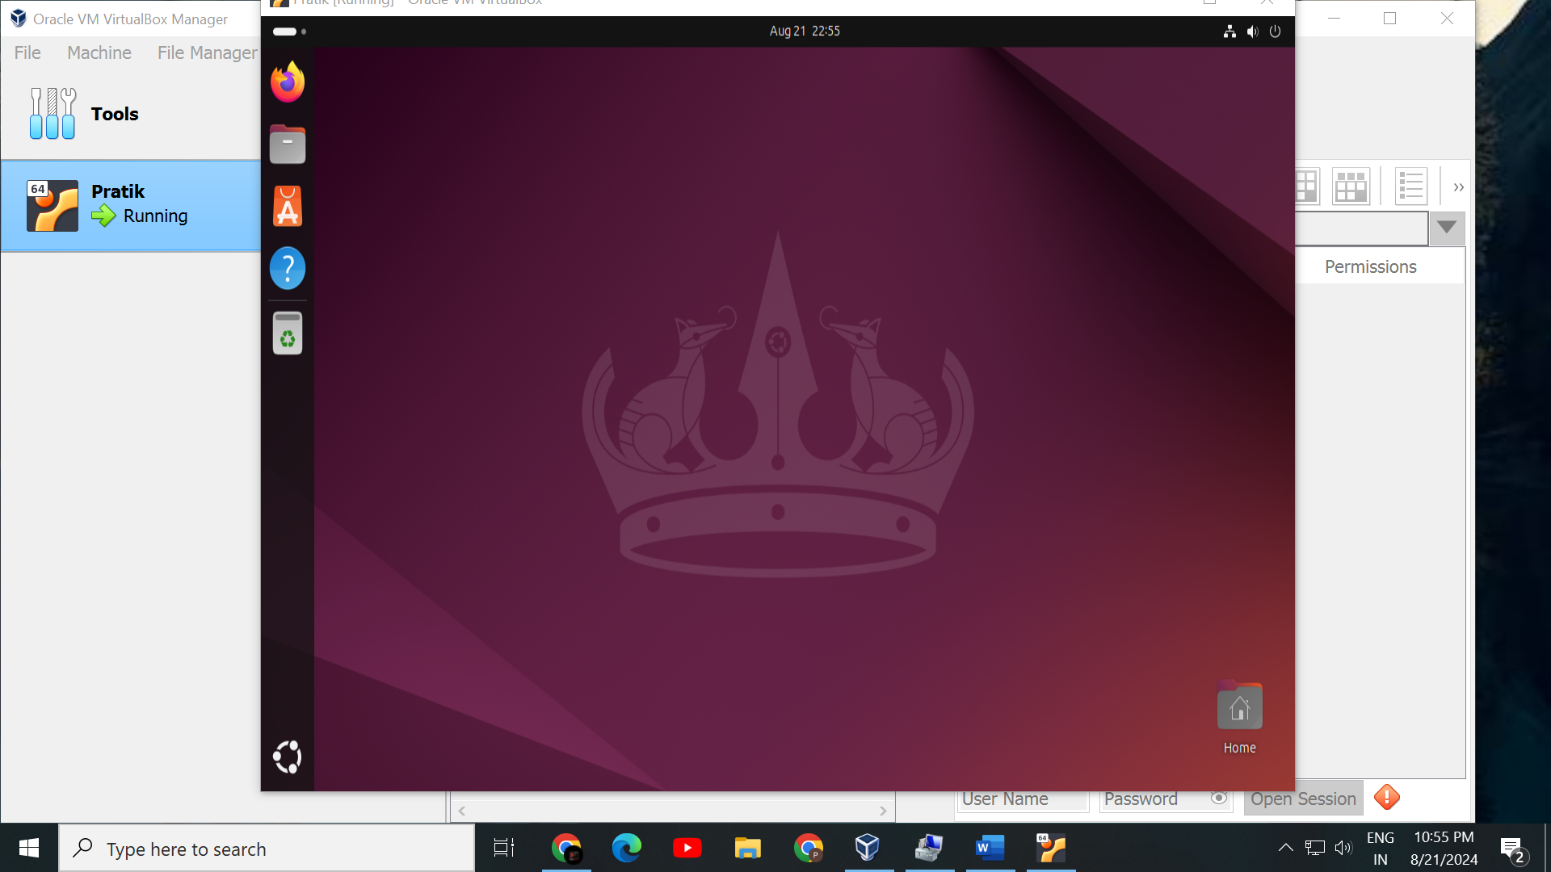

**Conclusion:**

By following these steps, you've successfully installed Linux in VirtualBox. This virtual environment allows you to explore and use Linux without affecting your main operating system.